Elliot Parrish
PHYS 410
Scientific Programming
Homework 6

  - There are 4535 lines in the file.
  - There are 4202 stores in the continental US.

    - CA Population Density: 182,160 [Persons/Store]
    - GA Population Density: 65,584 [Persons/Store]
    - CA Area Density: 768.53 [mi^2/Store]
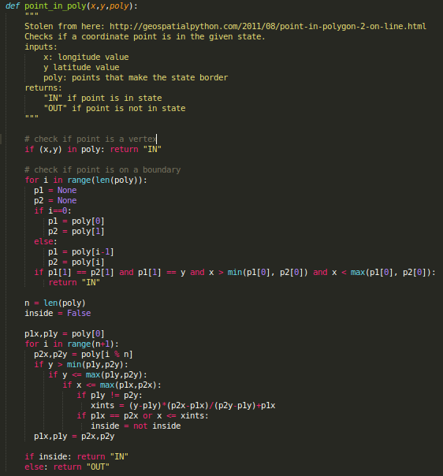
    - GA Area Density: 385.88 [mi^2/Store]

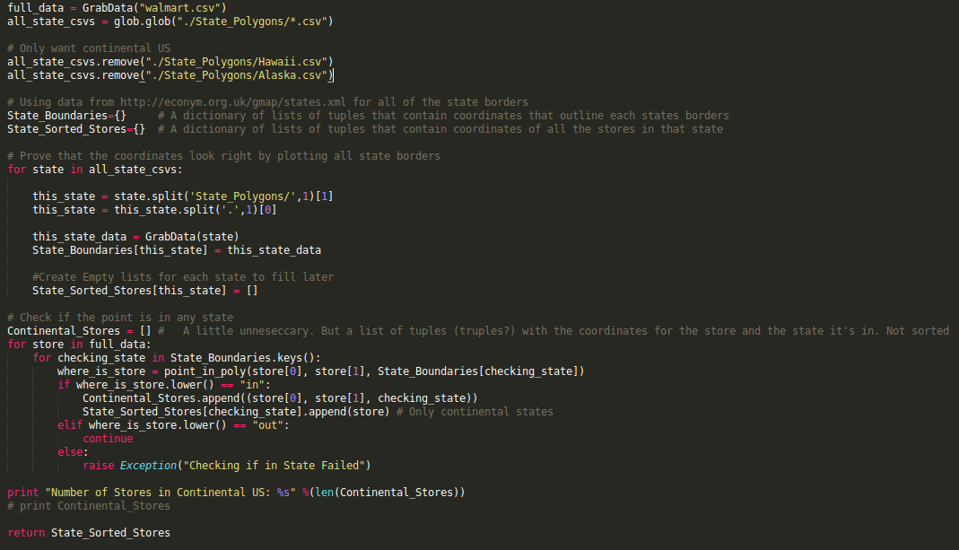
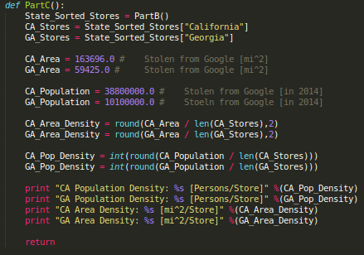

- Clustering First Pass

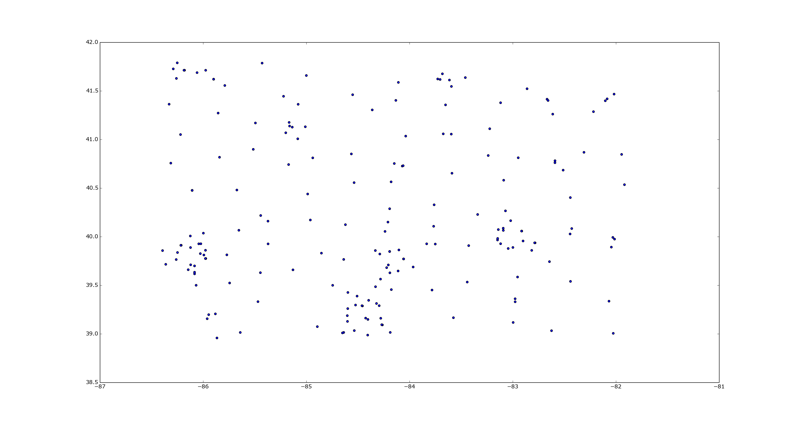

  - There are three distinct clusters on the lower half on the plot. This window box is in the Midwest, the circular looking cluster on the right at about -83 longitude and 40 latitude is the city of Columbus, Ohio; Cincinnati and Indianapolis can also be seen.

